Contents

1. Log in Cedar Compute Canada 2

2. Install GEM-MACH 3

3. Install python-based scheduler CYLC 5

4. Configure and run CYLC 6

# 1. Log in Cedar Compute Canada

The Compute Canada has 6 cluster, including Cedar (<https://docs.alliancecan.ca/wiki/Cedar>). First go to Compute Canada website (<https://ccdb.alliancecan.ca/security/login>) to register an account. At the upper-left menu, select “My Account” → “Apply for a New Role”. Here, fill out the information of PI who will sponsor you to use Compute Canada resources. The Compute Canada requires a multifactor authentication when users attempt to log in clusters. Install “Duo Mobile” app on your cell phone and link to the account on the Compute Canada website (upper-left menu → “My Account” → “Multifactor Authentication Management” → “Duo Mobile”). Then log in the Cedar Cluster (cedar.alliancecan.ca) with the username & password from Compute Canada website and a passcode from “Duo Mobile” app.

* ssh -Y username@cedar.alliancecan.ca

where username is the username registered on the Compute Canada website. The Cedar has three different directories for use, namely /home, /project, and /scratch. Only files and data (older than 60 days) under /scratch directory will be deleted by Cedar, thus remember to back up necessary files under /scratch to somewhere else (/project or physical disk). The /home directory has a storage of 50 GB where some scripts could be created but jobs cannot be submitted and programs cannot run. The /project directory is usually 10 TB where some important software can be installed and some necessary data can be backed up. The /scratch directory is the most commonly used place for software (e.g., GEM-MACH) installment and program running, as it has 20 TB storage.

# 2. Install GEM-MACH

Copy the GEM-MACH source code from Balbir’s directory

* cp -r /home/bpabla68/projects/def-yorkaqrl/bpabla68/os_v524_machOSrun5 /home/username/scratch/

where username is the username registered on the Compute Canada website. Then compile GEM-MACH under /scratch directory.

* module load StdEnv/2023 intel/2023.2.1 imkl/2023.2.0 openmpi/4.1.5 fftw/3.3.10
* cd /home/username/scratch/os_v524_machOSrun5
* . ./.common_setup intel
* . ./.initial_setup
* cado cmake-all-mach -DCOMPILER_SUITE=intel |& tee junk_cmakeAllmach.txt
* cado work -j 4 |& tee junk_work.txt

Once compiling is done, go to GEM-MACH bin directory (/home/username/scratch/os_v524_machOSrun5/work*/bin/) and make sure **maingemdm** is there. Then go to GEM-MACH source directory (/home/username/scratch/os_v524_machOSrun5/build*/src/gem/), view **maingemdm.map** and make sure **chm_exe** is linked from **libmach.a** instead of **chm_stub** library.

Then create configurations in GEM-MACH.

* cd /home/username/scratch/os_v524_machOSrun5
* cp -r /home/bpabla68/projects/def-yorkaqrl/bpabla68/os_v524_machOSrun5/share .
* cd /home/username/scratch/os_v524_machOSrun5/work*
* ln -s /home/username/scratch/os_v524_machOSrun5/share/configurations .

Copy GEM-MACH test input data from Balbir’s directory.

* cp -r /home/bpabla68/projects/def-yorkaqrl/bpabla68/os_v524_machOSrun5_indata /home/username/scratch/
* cd /home/username/scratch/os_v524_machOSrun5
* ln -s /home/username/scratch/os_v524_machOSrun5_indata/rpndata_dfiles/dfiles gem_dbase

Go to configurations (/home/username/scratch/os_v524_machOSrun5/share/configurations/os_v524_machOSrun5/cfg_0000/) and edit the path (red box) in **configexp.cfg**, as below. Here, username is set as hao11g as an example.

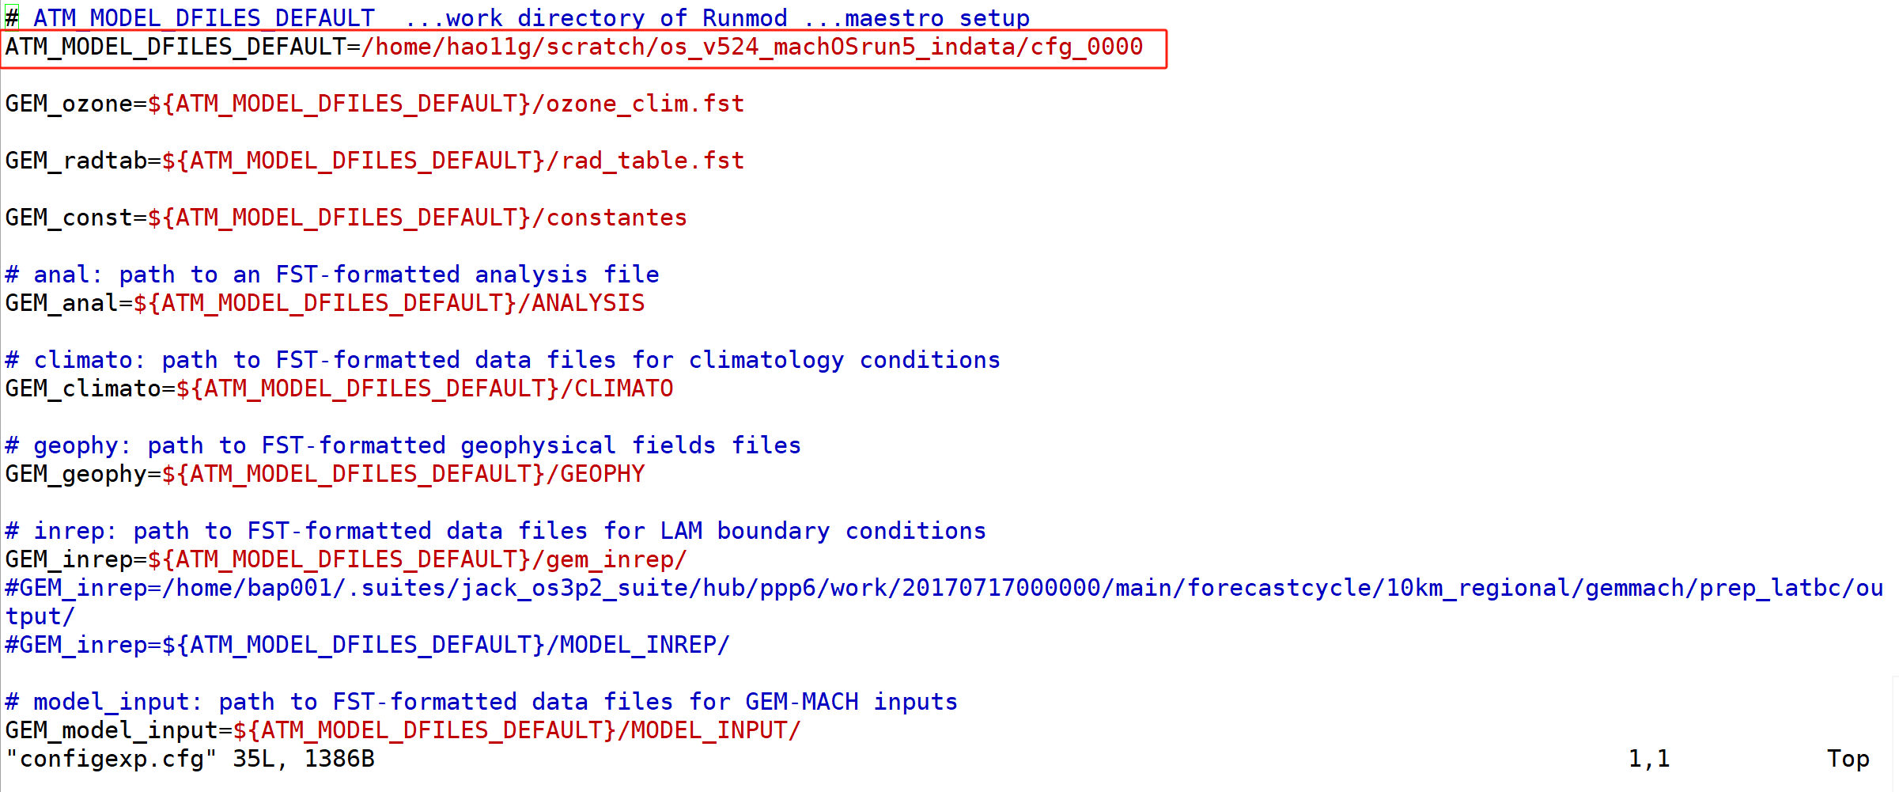

# 3. Install python-based scheduler CYLC

Go to /project directory where data won’t be deleted by Cedar after 2 months.

* mkdir /home/username/projects/def-yorkaqrl/username
* cd /home/username/projects/def-yorkaqrl/username/

where username is the username registered on the Compute Canada website. Note that **def-yorkaqrl** may be different and it is the group name of PI who sponsors you to use Compute Canada. Then load Python Package.

* module load python

Create the virtual environment for CYLC, then a folder named ENV appears.

* cd /home/username/projects/def-yorkaqrl/username/
* virtualenv --no-download ENV

Activate the virtual environment.

* cd /home/username/projects/def-yorkaqrl/username/
* source ENV/bin/activate

Upgrade pip software under the virtual environment.

* pip install --no-index --upgrade pip

Install CYLC software in the virtual environment, then will find the CYLC source code (/home/username/projects/def-yorkaqrl/username/ENV/lib/python3.11/site-packages/cylc/flow).

* pip install cylc-flow

To exit the virtual environment, simply enter the command.

* deactivate

Whenever want to use CYLC, activate the virtual environment (cd & source commands). After using CYLC, quit the virtual environment (deactivate command).

* cd /home/username/projects/def-yorkaqrl/username/
* source ENV/bin/activate
* deactivate

# 4. Configure and run CYLC

Go to /project directory and activate the virtual environment.

* cd /home/username/projects/def-yorkaqrl/username/
* source ENV/bin/activate

Create CYLC folder and the CYLC configure file.

* cd /home/username/projects/def-yorkaqrl/username/
* mkdir cylc-src
* touch flow.cylc

Edit the configure file as figure below. Remember to change the username in **MY_DEFAULT_PATH** (red box).

* gedit flow.cylc

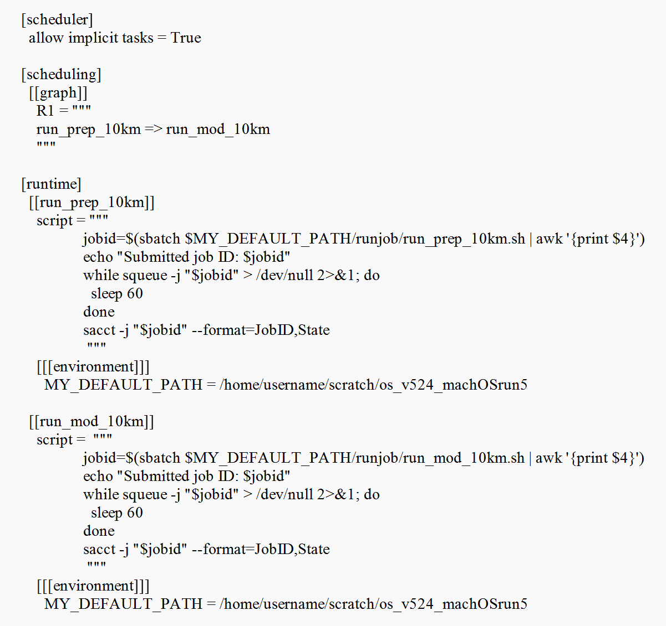

Visualise the workflow to check the flow chart and the created flow chart figure could be found at /tmp directory.

* cd /home/username/projects/def-yorkaqrl/username/cylc-src
* cylc graph .

Install CYLC configure file by

* cylc install --workflow-name=gemmach --run-name=test

where the name of workflow is defined as **gemmach** and the name of running job is defined as **test**. The CYLC work folder is created at /home directory (/home/username/cylc-run/gemmach/test).

Move CYLC workflow (gemmach folder) from /home directory to /scratch directory and then create a symlink at /home directory. Because CYLC 8 always installs the work folder at /home directory where GEM-MACH running job will be submitted later. However, Compute Canada does not allow users to submit running jobs from /home directory. Thus, when want to run CYLC, remember to move created CYLC workflow to /scratch directory and create a symlink at /home directory. The workflow at /scratch directory will be used to submit GEM-MACH running job to Compute Canada and store CYLC log files. The symlink of workflow at /scratch directory is used for CYLC running.

* cd /home/username/cylc-run
* mkdir /home/username/scratch/cylc-run
* mv gemmach /home/username/scratch/cylc-run/
* ln -s /home/username/scratch/cylc-run/gemmach .

Create shell scripts (**run_prep_10km.sh** and **run_mod_10km.sh**) under a new folder named runjob (as red box in figure below) for submitting GEM-MACH running job.

* mkdir /home/username/scratch/os_v524_machOSrun5/runjob

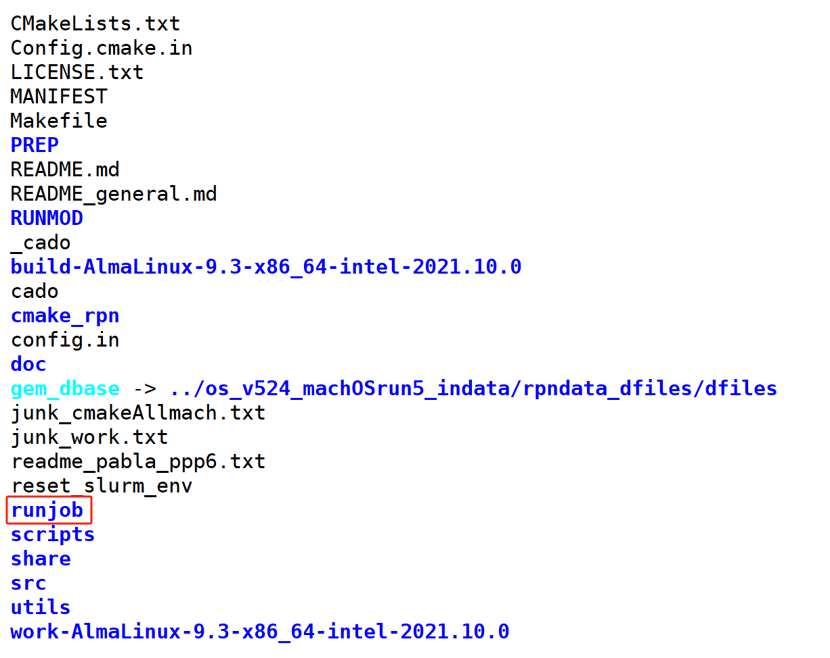

Edit PI account, username and email address in the shell scripts under /runjob folder, as an example below.

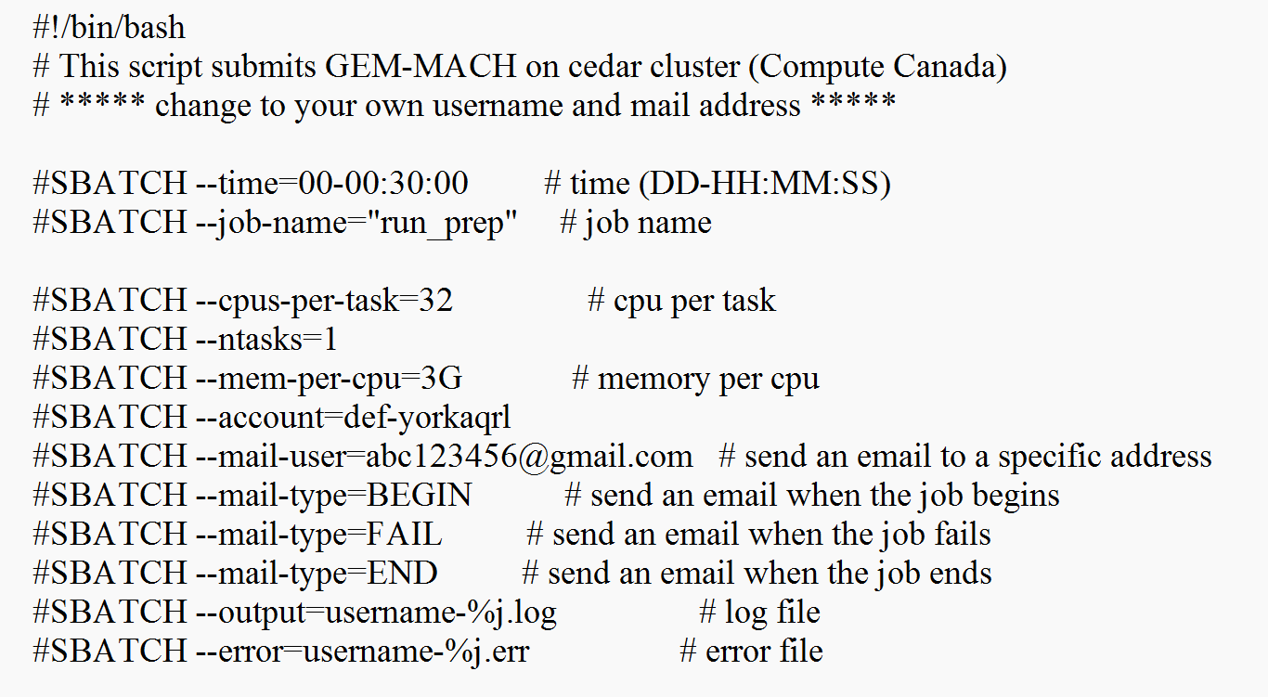

Run CYLC job (format is “cylc play workflow/job”).

* cylc play gemmach/test

Check CYLC log files by entering CYLC job folder. Under /test folder, /work includes job log files (username-%j.log and username-%j.err) from Compute Canada and /log includes all log files created by CYLC. Under /log folder, /scheduler shows the task schedule and /job shows log, error, and output for each task.

* cd /home/username/cylc-run/gemmach/test

(scheduler directory shows the task schedule and job directory shows log, error, and output for each task)

Finally, exit the virtual environment.

* deactivate